DIS-AM,C-Taino-Cemi-Death Figure

 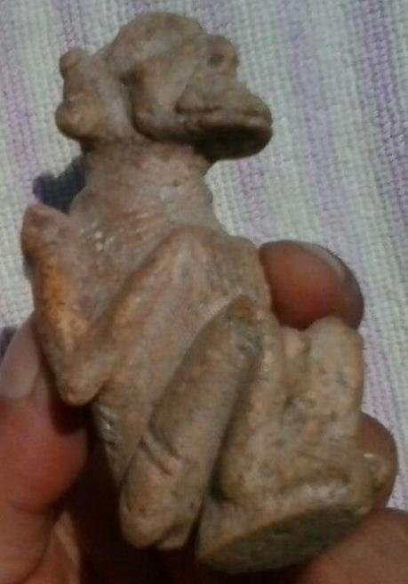

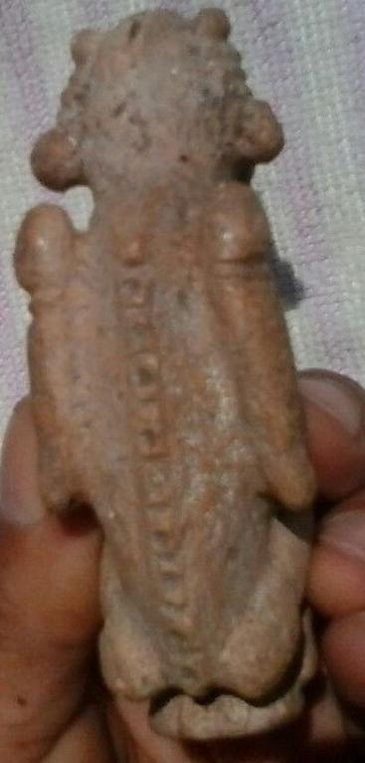

# Order details

## Sales order

Sold by [artetaino](http://myworld.ebay.com/artetaino) ( [16](http://feedback.ebay.com/ws/eBayISAPI.dll?ViewFeedback&userid=artetaino) )

### Delivery package 1 of 1

Estimated delivery Wednesday, Apr 6, 2016 - Wednesday, Apr 13, 2016



#### [Taino Zemi Pre Columbian](http://www.ebay.com/itm/152024056864)

|  |  |
| --- | --- |
| Item price | $250.00 |
| Quantity | 1 |
| Item number | 152024056864 |
| Shipping service | Standard Shipping from outside US |

## Shipping address

Ralph J Coffman Jr

149 Atlantic Ave

Swampscott MA 01907-2427

United States

## Order total

|  |  |
| --- | --- |
| Subtotal | $250.00 |
| Shipping | $60.00 |

**Total**

$310.00